0B – Gauss’ Law

Topics: Gauss’ law, symmetries, electric field from a line charge distribution.

Summary: Students consider the symmetry of a line charge distribution to argue for why the electric field is entirely in the radial direction, and why a Gaussian cylinder is needed to solve for the electric field (instead of a sphere or a cube). Students are then asked to recall Gauss’ law in integral form, find the charge contained in a section of wire, and solve for the electric field.

Written by: Michael Dubson, Charles Baily and Steven Pollock.

Contact: Steven.Pollock@Colorado.EDU

Comments: Students should be able to complete these tasks within 15 minutes. This is meant to be a short review activity, so the time-estimate is based on students already having a reasonable familiarity with using Gauss’ law to solve for a field. The wording in this version is slightly altered from the original, which was less explicit about having them make symmetry arguments for the lack of longitudinal and tangential components. Many of our students were more inclined to argue in terms of the curl (or closed line integral) of an electrostatic field. Some misinterpreted the vectors in the diagrams as field lines, and argued that they can only begin and end on charges. Many had difficulty briefly articulating their reasoning on the symmetry questions, but the final calculations were fairly straightforward for them. In pre-tests for this class, and post-tests for the first semester, a significant number of students have stated that the field could be solved for using Gauss’ law and a non-symmetric surface, but that we don’t use such surfaces because the integral would be too difficult to calculate. All of this indicates that students for the most part have the rote application of Gauss’ law down, without necessarily having a strong grasp of the important role of symmetry in using it to solve for the field. We have included two optional “challenge” questions at the end, regarding Stokes’ theorem and Ampere’s law, for students who are quick to finish the first part of the activities.
A. Symmetries: Consider a long straight wire with uniform charge per unit length . We will use Gauss’ law to determine the electric field around the wire. Usually, we begin by assuming that the electric field around the charged wire is entirely in the radial direction.
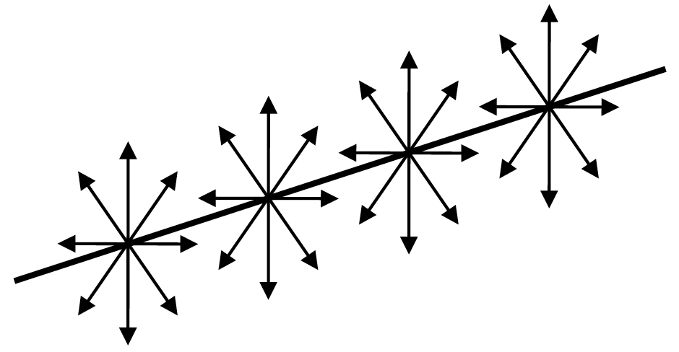

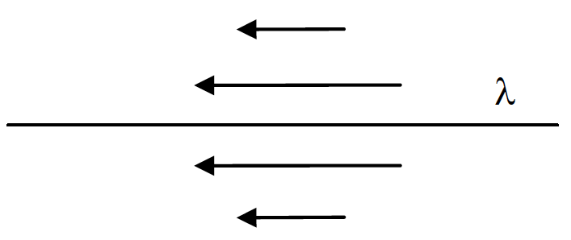
Give a brief symmetry argument for why the electric field should not have a longitudinal component (parallel with the wire).

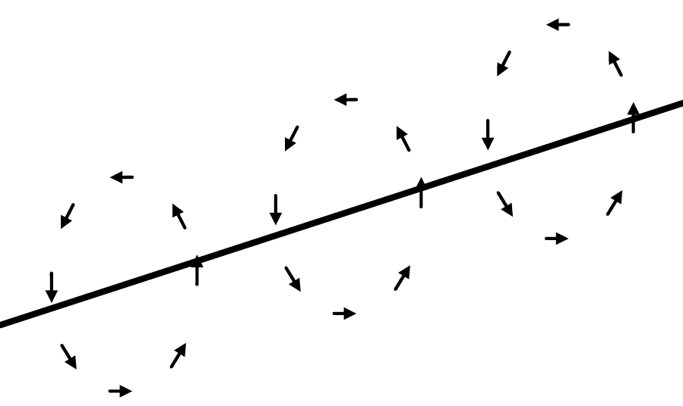
Give a brief symmetry argument for why the electric field should not have a tangential component (circling around the wire).

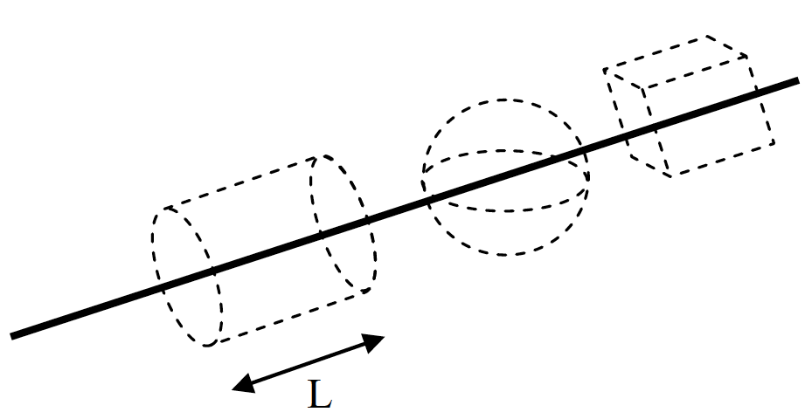
Assuming the electric field is purely radial, why would we choose an imaginary cylinder as our Gaussian surface? Why not a sphere or a cube?

B. Here is Gauss’ law in differential form:

Now, write down Gauss’ law in integral form.

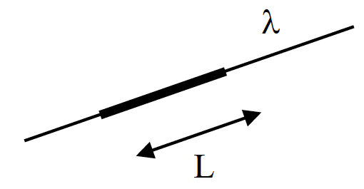
What is the total charge on a section of wire of length L?

Use Gauss’ law in integral form to solve for the electric field around the wire. Briefly define any symbols you use.

Challenge Questions: (for the really fast teams)

Write down Stokes’ theorem (the “curl theorem”).

Use Stokes’ theorem to derive the integral form of Ampere’s law from its differential form:

Be sure to briefly explain each of your steps.

